|  |
| --- |
|  |
| **Versal AI Edge Series**  **Development board user manual** |
| **VD100** |
| REV version 1.0 |
|  |
|  |

|  |
| --- |
| **Xinyi Electronic Technology (Shanghai) Co., Ltd. www.alinx.com** |

Table of contents

Directory 2

1. Introduction to development board 5

2. VE2302 core board 7

(1) Introduction 7

(2) VE2302 9

(3) Clock configuration 10

(4) DDR4 DRAM 11

(5) QSPI Flash 16

(6) eMMC Flash 17

(7) LED lights 19

(8) Power supply 19

(9) Expansion interface 21

(10) Structure diagram 27

3. Expansion board 27

(1) Introduction 27

(2) Gigabit Ethernet interface 28

(3) PCIe3.0 X4 interface 30

(4) Optical fiber interface 32

(5) USB to serial port 33

(6) USB2.0 interface 34

(7) LVDS display interface 35

(8) MIPI interface 36

(9) SD card 38

(10) EEPROM 24LC04 and temperature sensor 39

(11) JTAG interface 39

(12) CANFD communication interface 40

(13) Expansion port 41

(14) Button 42

(15) LED lights 43

(16) Power supply 44

(17) Structural Dimensions Diagram 45

The Adaptive Computing Acceleration Platform (ACAP) (Model: VD100) of the ALINX Versal AI Edge series has been officially released. In order to let you quickly understand this development platform, we have written this user manual.

This Versal AI Edge development platform uses a core board plus expansion board model to facilitate users’ secondary development and utilization of the core board. In the baseboard design, we used 1 1 2-pin PMOD interface, 2 10G optical fiber interfaces, 2 Ethernet ports, 2 MIPI interfaces, 1 USB2.0 interface, 1 UART interface and 1 PCIe3.0X4 interface. It meets users' requirements for high-speed data transmission and exchange and is a "professional-level" and "all-around-level" development platform for data communications. I believe that such a product is very suitable for students, engineers and other groups engaged in artificial intelligence, data acceleration and video image processing.

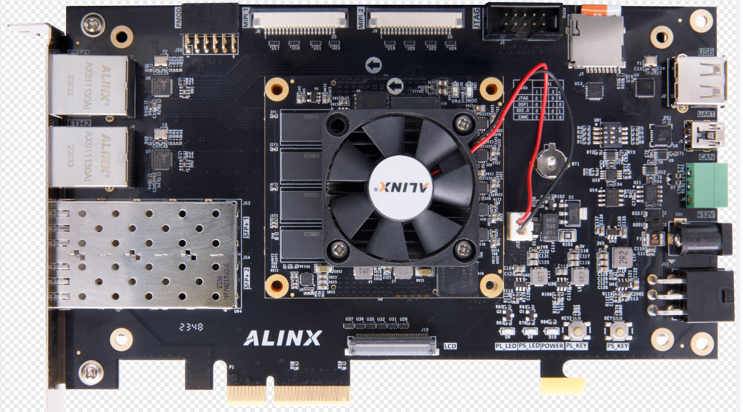

# Development board introduction

Here, a brief function introduction of this Versal AI VD100 platform is given.

The entire structure of the development board is designed based on our consistent core board + expansion board model. The core board and the expansion board are connected using high-speed inter-board connectors.

The core board is mainly composed of Versal AI VE2302 + 4 DDR4 + QSPI FLASH + EMMC. The VE2302 chip of the Versal AI Series we selected is packaged in SFVA784. The data bit width of VE2302 and DDR4 is 64 bits, the capacity of DDR4 is up to 4GB, and the data rate is 3200bps. Meet the need for high buffers during data processing. In addition, there are 8G EMMC and 512Mbit QSPI FLASH on the core board for system startup and data storage.

The base board is equipped with a wealth of peripheral interfaces. The following figure is a schematic structural diagram of the entire VD100 platform:



Through this schematic diagram, we can see the functions that our development platform can achieve.

* Versal AI VE2302 core board

It is composed of VE2302+4GB DDR4+8G EMMC+512Mb QSPI FLASH, and there are two high-precision Sitime crystal oscillators, one is single-ended 33.3333MHz, the other is differential 200MHz, providing stable clock input for the VE2302 system and logic unit.

* 1 0/100M /1000M Ethernet RJ-45 interface

2-way Gigabit Ethernet interface, the chip uses Jinglue Company's JL2121 Ethernet PH Y chip to provide users with network communication services. JL2121 The chip supports 10/100/1000 Mbps network transmission rate; full duplex and adaptive.

* USB Uart debugging interface

1-way Uart to USB interface, used to communicate with the computer to facilitate user debugging. The serial port chip uses the USB- UAR chip of Silicon Labs CP210 2 GM , and the USB interface uses the MINI USB interface.

* PCIe x 4 interface

Supports PCI Express 3.0 standard and provides standard PCIe x 4 high - speed data transmission interface.

* Micro SD card holder

1-way Micro SD card holder for storing operating system images and file systems .

* USB2.0 interface

1 high-speed USB2.0 interface can be used to connect the development board to USB peripherals such as mouse, keyboard, and USB flash drive.

* MIPI interface

2-way MIPI interface, supports MIPI 4xLane, can be connected to ALINX MIPI camera (AN5010) .

* LVDS interface

1-way LVDS interface, used to connect to ALINX’s LVDS display.

* 2-way SFP+ optical fiber interface

The 2-channel high-speed transceiver of the GTY transceiver is connected to the sending and receiving of 2 optical modules to realize 2-channel high-speed optical fiber communication interface. The optical fiber data communication reception and transmission speed of each channel is as high as 12.5Gb/s.

* CAN communication interface

1-way CAN/CAN FD bus interface uses TI's TJA1051T chip, and the interface uses a 3-Pin green terminal block .

* 12-pin PMOD expansion port

One 12-pin 2.54mm pitch expansion IO port is reserved. The expansion port includes 2 channels of 3.3V power supply, 2 channels of ground, and 8 channels of 3.3V IO ports.

* JTAG port

10-pin 2.54mm standard JTAG port for downloading and debugging VE2302 programs;

* button

There are 2 user buttons on the expansion board, one connected to the MIO of the PS and one connected to the IO of the PL;

* LED light

5 LEDs (2 on the core board and 3 on the expansion board);

# VE2302 core board

## Introduction

The V100 ( **core board model, the same below** ) core board is a high-performance core board developed based on the XCVE2302-SFVA784-1LP-ES chip of XILINX's Versal ACAP series. It has high performance, low latency, edge computing, and low power. It has characteristics such as high power consumption and is suitable for use in data centers, video image processing, high-speed data processing, etc.

This core board uses 4 pieces of MT40A512M16LY-062E from MICRON.

This DDR4 chip has 64-bit data bus bandwidth and 4GB capacity; the maximum operating speed of DDR4 SDRAM can reach 1600MHz (data rate 3200Mbps). In addition, the core board also integrates two 256MBit QSPI FLASH and one 8GB EMMC chip for startup storage configuration and system files.

The PS side of this core board has expanded 53 1.8V level standard MIOs, and the PL side has expanded 22 3.3V level standard IOs, 54 1.8V level standard IO ports, and 30 1.2V level standard IOs. There are also 8 pairs of GTY high-speed RX/TX differential signals. Moreover, the wiring between the FPGA chip and the interface has been processed with equal length and differential processing, and the size of the core board is only 65*60 (mm), which is very suitable for secondary development.

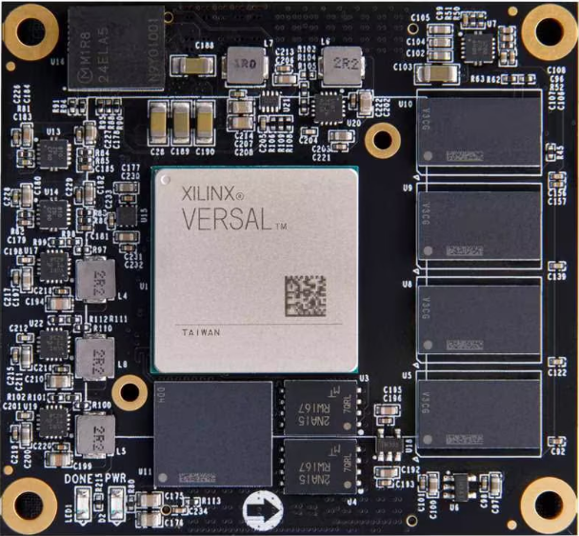

V100 core board front view

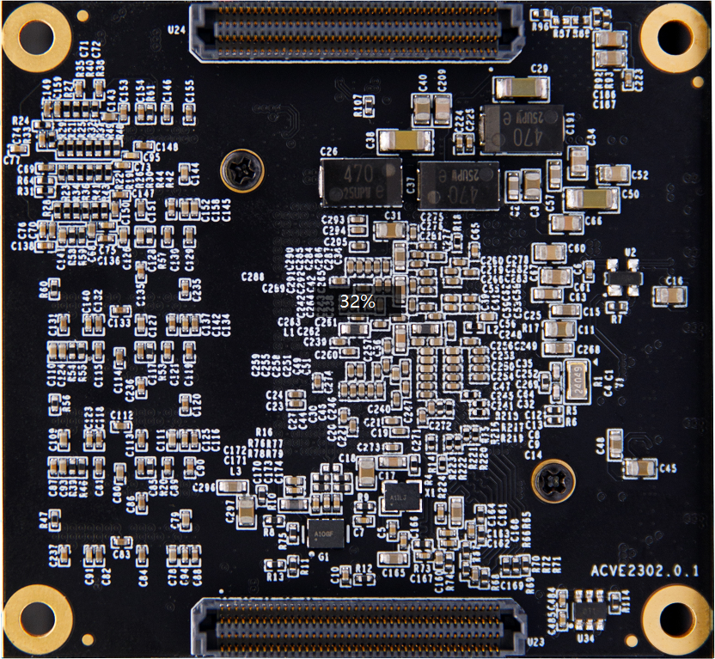

V100 core board back view

## VE2302

As mentioned before, the Versal ACAP model we use is XCVE2302-SFVA784-1LP-ES, the speed level is 1, the operating temperature is 0~100 ℃ , and the package is SFVA784. The chip naming rules of Versal ACAP are as follows:

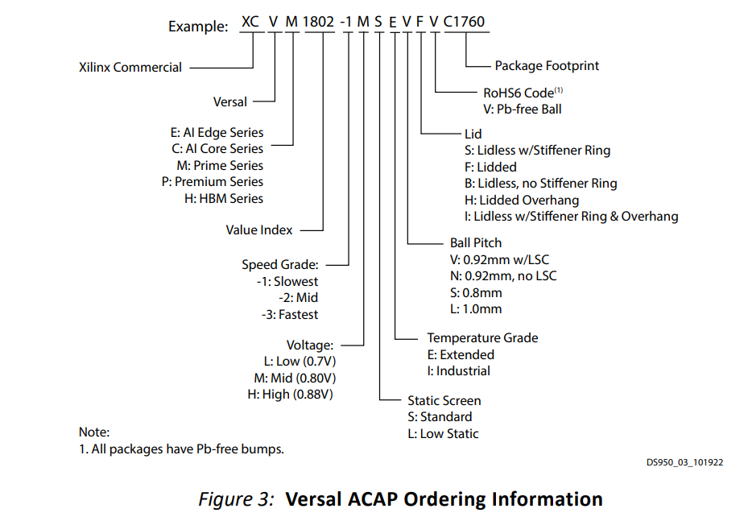

The VE2302 chip integrates 4 ARM Cortex™-A 72 processors and 2 Cortex -R5F processors , as well as 34 AI Engines-ML acceleration units and 464 DSP processing units. The internal resources of VE2302 are as follows:

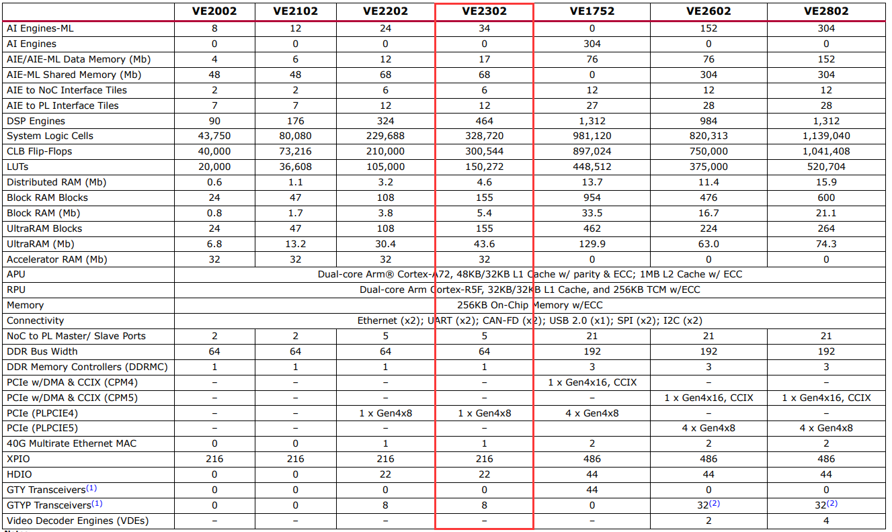

## Clock configuration

The V100 core board provides a reference clock and an RTC real-time clock for the PS system and PL logic parts respectively, so that the PS system and PL logic can work independently. The schematic diagram of the clock circuit design is shown in Figure 2-3-1 below :



Figure 2- 3-1 Core board clock source

**PS system RTC real-time clock**

The passive crystal Y1 on the core board provides a 3 2.768K Hz real-time clock source for the PS system . The crystal is connected to the RTC_PADI_503 and RTC_PAD O_503 pins of BANK503 of the VE2302 chip .

**PS system clock source**

1 crystal oscillator on the core board provides a 33.333MHz clock input to the PS system . The clock input is connected to the PS_REF_CLK_503 pin of BANK503 of the VE2302 chip.

**PL system clock source**

The board provides a differential 200MHz PL system clock source for the reference clock of the DDR4 controller. The crystal oscillator output is connected to the global clock (GC) of PL BANK701. This global clock can be used to drive the DDR4 controller and user logic circuits in the FPGA.

**PL clock pin assignment:**

|  |  |  |
| --- | --- | --- |
| Signal name | VE2302 pin name | VE2302 pin number |
| PL_CLK0_N | I O_L24N_GC_XCC_N8P1_M0P103_701 | AC23 |
| PL_CLK0_P | IO_L24P_GC_XCC_N8P0_M0P102_701 | AB23 |

## DDR4 DRAM

The V100 core board is equipped with 4 Micron 1GB DDR 4 chips, model MT40A512M16LY-062E . The 4 DDR4 chips are hung on the XPIO of BANK700, 701 and 702 to form a 64-bit data bus bandwidth and 4GB capacity . . DDR 4 SDRAM operates at a maximum speed of 1600 MHz (data rate 3200Mbps) . The specific configuration of DDR 4 SDRAM is shown in Table 2-4-1 below .

|  |  |  |  |
| --- | --- | --- | --- |
| **bit number** | **Chip model** | **capacity** | **factory** |
| U5, U 8 , U 9, U10 | MT40A512M16LY-062E | 512M x 16bit | Micron |

Table 2-4-1 DDR 4 SDRAM configuration

The hardware design of DDR4 requires strict consideration of signal integrity. We have fully considered matching resistors/terminal resistors, trace impedance control, and trace equal length control during circuit design and PCB design to ensure the high-speed and stable operation of DDR4. The hardware connection method of DDR4 is shown in Figure 2-4-1 :



Figure 2-4-1 DDR4 DRAM schematic part

**DDR4 SDRAM pin assignment:**

|  |  |  |
| --- | --- | --- |
| **Signal name** | **Pin name** | **Pin number** |
| PL_DDR4_A0 | IO_L18P_XCC_N6P0_M0P36_700 | AB12 |
| PL_DDR4_A1 | IO_L17N_N5P5_M0P35_700 | AE22 |
| PL_DDR4_A2 | IO_L17P_N5P4_M0P34_700 | AD22 |
| PL_DDR4_A3 | IO_L20P_N6P4_M0P40_700 | AB15 |
| PL_DDR4_A4 | IO_L12P_GC_XCC_N4P0_M0P24_700 | AD12 |
| PL_DDR4_A5 | IO_L26P_N8P4_M0P52_700 | AE17 |
| PL_DDR4_A6 | IO_L24P_GC_XCC_N8P0_M0P48_700 | AD16 |
| PL_DDR4_A7 | IO_L6N_GC_XCC_N2P1_M0P13_700 | AG11 |
| PL_DDR4_A8 | IO_L25N_N8P3_M0P51_700 | AE14 |
| PL_DDR4_A9 | IO_L19P_N6P2_M0P38_700 | AB14 |
| PL_DDR4_A10 | IO_L21N_XCC_N7P1_M0P43_700 | AB17 |
| PL_DDR4_A11 | IO_L25P_N8P2_M0P50_700 | AE13 |
| PL_DDR4_A12 | IO_L0N_XCC_N0P1_M0P1_700 | AH12 |
| PL_DDR4_A13 | IO_L24N_GC_XCC_N8P1_M0P49_700 | AD15 |
| PL_DDR4_CLK_N | IO_L15N_XCC_N5P1_M0P31_700 | AD19 |
| PL_DDR4_CLK_P | IO_L15P_XCC_N5P0_M0P30_700 | AC19 |
| PL_DDR4_BA0 | IO_L20N_N6P5_M0P41_700 | AC16 |
| PL_DDR4_BA1 | IO_L12N_GC_XCC_N4P1_M0P25_700 | AD11 |
| PL_DDR4_WE_B | IO_L16N_N5P3_M0P33_700 | AD21 |
| PL_DDR4_CAS_B | IO_L14N_N4P5_M0P29_700 | AD17 |
| PL_DDR4_CS_B | IO_L14P_N4P4_M0P28_700 | AC17 |
| PL_DDR4_ACT_B | IO_L18N_XCC_N6P1_M0P37_700 | AC11 |
| PL_DDR4_RAS_B | IO_L19N_N6P3_M0P39_700 | AC13 |
| PL_DDR4_BG0 | IO_L21P_XCC_N7P0_M0P42_700 | AB18 |
| PL_DDR4_ODT | IO_L23N_N7P5_M0P47_700 | AC22 |
| PL_DDR4_CKE | IO_L23P_N7P4_M0P46_700 | AB21 |
| PL_DDR4_RST | IO_L25P_N8P2_M0P104_701 | AC24 |
| PL_DDR4_DQS0_N | IO_L9N_GC_XCC_N3P1_M0P19_700 | AG16 |
| PL_DDR4_DQS0_P | IO_L9P_GC_XCC_N3P0_M0P18_700 | AG17 |
| PL_DDR4_DQS1_N | IO_L3N_XCC_N1P1_M0P7_700 | AH19 |
| PL_DDR4_DQS1_P | IO_L3P_XCC_N1P0_M0P6_700 | AG20 |
| PL_DDR4_DQS2_N | IO_L6N_GC_XCC_N2P1_M0P67_701 | AD27 |
| PL_DDR4_DQS2_P | IO_L6P_GC_XCC_N2P0_M0P66_701 | AC28 |
| PL_DDR4_DQS3_N | IO_L3N_XCC_N1P1_M0P61_701 | AF23 |
| PL_DDR4_DQS3_P | IO_L3P_XCC_N1P0_M0P60_701 | AF24 |
| PL_DDR4_DQS4_N | IO_L15N_XCC_N5P1_M0P85_701 | AA23 |
| PL_DDR4_DQS4_P | IO_L15P_XCC_N5P0_M0P84_701 | Y24 |
| PL_DDR4_DQS5_N | IO_L21N_XCC_N7P1_M0P97_701 | Y27 |
| PL_DDR4_DQS5_P | IO_L21P_XCC_N7P0_M0P96_701 | Y28 |
| PL_DDR4_DQS6_N | IO_L0N_XCC_N0P1_M0P109_702 | U28 |
| PL_DDR4_DQS6_P | IO_L0P_XCC_N0P0_M0P108_702 | U27 |
| PL_DDR4_DQS7_N | IO_L9N_GC_XCC_N3P1_M0P127_702 | N27 |
| PL_DDR4_DQS7_P | IO_L9P_GC_XCC_N3P0_M0P126_702 | P26 |
| PL_DDR4_DM0 | IO_L6P_GC_XCC_N2P0_M0P12_700 | AG12 |
| PL_DDR4_DM1 | IO_L0P_XCC_N0P0_M0P0_700 | AH13 |
| PL_DDR4_DM2 | IO_L9P_GC_XCC_N3P0_M0P72_701 | AE28 |
| PL_DDR4_DM3 | IO_L0P_XCC_N0P0_M0P54_701 | AD24 |
| PL_DDR4_DM4 | IO_L12P_GC_XCC_N4P0_M0P78_701 | V22 |
| PL_DDR4_DM5 | IO_L18P_XCC_N6P0_M0P90_701 | V28 |
| PL_DDR4_DM6 | IO_L3P_XCC_N1P0_M0P114_702 | N28 |
| PL_DDR4_DM7 | IO_L6P_GC_XCC_N2P0_M0P120_702 | U25 |
| PL_DDR4_DQ0 | IO_L8P_N2P4_M0P16_700 | AF14 |
| PL_DDR4_DQ1 | IO_L10N_N3P3_M0P21_700 | AG18 |
| PL_DDR4_DQ2 | IO_L8N_N2P5_M0P17_700 | AG15 |
| PL_DDR4_DQ3 | IO_L10P_N3P2_M0P20_700 | AF18 |
| PL_DDR4_DQ4 | IO_L7P_N2P2_M0P14_700 | AF13 |
| PL_DDR4_DQ5 | IO_L11N_N3P5_M0P23_700 | AF19 |
| PL_DDR4_DQ6 | IO_L7N_N2P3_M0P15_700 | AG13 |
| PL_DDR4_DQ7 | IO_L11P_N3P4_M0P22_700 | AE19 |
| PL_DDR4_DQ8 | IO_L2P_N0P4_M0P4_700 | AH17 |
| PL_DDR4_DQ9 | IO_L4P_N1P2_M0P8_700 | AG21 |
| PL_DDR4_DQ10 | IO_L2N_N0P5_M0P5_700 | AH18 |
| PL_DDR4_DQ11 | IO_L4N_N1P3_M0P9_700 | AH20 |
| PL_DDR4_DQ12 | IO_L1P_N0P2_M0P2_700 | AH14 |
| PL_DDR4_DQ13 | IO_L5N_N1P5_M0P11_700 | AH22 |
| PL_DDR4_DQ14 | IO_L1N_N0P3_M0P3_700 | AH15 |
| PL_DDR4_DQ15 | IO_L5P_N1P4_M0P10_700 | AG22 |
| PL_DDR4_DQ16 | IO_L8N_N2P5_M0P71_701 | AF26 |
| PL_DDR4_DQ17 | IO_L7N_N2P3_M0P69_701 | AE26 |
| PL_DDR4_DQ18 | IO_L10N_N3P3_M0P75_701 | AH27 |
| PL_DDR4_DQ19 | IO_L8P_N2P4_M0P70_701 | AE27 |
| PL_DDR4_DQ20 | IO_L11N_N3P5_M0P77_701 | AG27 |
| PL_DDR4_DQ21 | IO_L7P_N2P2_M0P68_701 | AD26 |
| PL_DDR4_DQ22 | IO_L11P_N3P4_M0P76_701 | AG26 |
| PL_DDR4_DQ23 | IO_L10P_N3P2_M0P74_701 | AG28 |
| PL_DDR4_DQ24 | IO_L1N_N0P3_M0P57_701 | AE24 |
| PL_DDR4_DQ25 | IO_L1P_N0P2_M0P56_701 | AD25 |
| PL_DDR4_DQ26 | IO_L5P_N1P4_M0P64_701 | AH24 |
| PL_DDR4_DQ27 | IO_L2P_N0P4_M0P58_701 | AF25 |
| PL_DDR4_DQ28 | IO_L4P_N1P2_M0P62_701 | AG23 |
| PL_DDR4_DQ29 | IO_L2N_N0P5_M0P59_701 | AG25 |
| PL_DDR4_DQ30 | IO_L4N_N1P3_M0P63_701 | AH23 |
| PL_DDR4_DQ31 | IO_L5N_N1P5_M0P65_701 | AH25 |
| PL_DDR4_DQ32 | IO_L17P_N5P4_M0P88_701 | Y22 |
| PL_DDR4_DQ33 | IO_L13P_N4P2_M0P80_701 | V23 |
| PL_DDR4_DQ34 | IO_L16P_N5P2_M0P86_701 | Y23 |
| PL_DDR4_DQ35 | IO_L13N_N4P3_M0P81_701 | W24 |
| PL_DDR4_DQ36 | IO_L16N_N5P3_M0P87_701 | AA22 |
| PL_DDR4_DQ37 | IO_L14P_N4P4_M0P82_701 | V24 |
| PL_DDR4_DQ38 | IO_L17N_N5P5_M0P89_701 | AA21 |
| PL_DDR4_DQ39 | IO_L14N_N4P5_M0P83_701 | W25 |
| PL_DDR4_DQ40 | IO_L19P_N6P2_M0P92_701 | V25 |
| PL_DDR4_DQ41 | IO_L20P_N6P4_M0P94_701 | W27 |
| PL_DDR4_DQ42 | IO_L22P_N7P2_M0P98_701 | AA28 |
| PL_DDR4_DQ43 | IO_L19N_N6P3_M0P93_701 | W26 |
| PL_DDR4_DQ44 | IO_L20N_N6P5_M0P95_701 | Y26 |
| PL_DDR4_DQ45 | IO_L23P_N7P4_M0P100_701 | AA26 |
| PL_DDR4_DQ46 | IO_L22N_N7P3_M0P99_701 | AB28 |
| PL_DDR4_DQ47 | IO_L23N_N7P5_M0P101_701 | AB26 |
| PL_DDR4_DQ48 | IO_L2P_N0P4_M0P112_702 | P27 |
| PL_DDR4_DQ49 | IO_L5P_N1P4_M0P118_702 | K27 |
| PL_DDR4_DQ50 | IO_L2N_N0P5_M0P113_702 | R28 |
| PL_DDR4_DQ51 | IO_L4N_N1P3_M0P117_702 | L28 |
| PL_DDR4_DQ52 | IO_L1P_N0P2_M0P110_702 | R27 |
| PL_DDR4_DQ53 | IO_L5N_N1P5_M0P119_702 | K28 |
| PL_DDR4_DQ54 | IO_L1N_N0P3_M0P111_702 | T28 |
| PL_DDR4_DQ55 | IO_L4P_N1P2_M0P116_702 | M27 |
| PL_DDR4_DQ56 | IO_L8P_N2P4_M0P124_702 | P25 |
| PL_DDR4_DQ57 | IO_L10N_N3P3_M0P129_702 | L26 |
| PL_DDR4_DQ58 | IO_L8N_N2P5_M0P125_702 | R26 |
| PL_DDR4_DQ59 | IO_L10P_N3P2_M0P128_702 | M26 |
| PL_DDR4_DQ60 | IO_L7P_N2P2_M0P122_702 | T25 |
| PL_DDR4_DQ61 | IO_L11N_N3P5_M0P131_702 | K26 |
| PL_DDR4_DQ62 | IO_L7N_N2P3_M0P123_702 | T26 |
| PL_DDR4_DQ63 | IO_L11P_N3P4_M0P130_702 | J25 |

## QSPI Flash

The core board uses two 256 M bit Q SPI FLASH chips, model MT25QU256ABA1EW9-0SIT, which uses the 1.8 V CMOS voltage standard. Due to its non-volatile characteristics, QSPI FLASH can be used as the boot image of the FPGA system during use . These images mainly include FPGA bit files, soft core application codes and other user data files.

The specific models and related parameters of QSPI FLASH are shown in the table below

|  |  |  |  |
| --- | --- | --- | --- |
| **bit number** | **Chip type** | **capacity** | **factory** |
| U3,U4 | MT25QU256ABA1EW9-0SIT | 256MB Bit | Micron |

Table 2-5-1 QSPI Flash models and parameters

BANK500 in the PS part of the Versal ACAP chip . In the system design, the MIO port functions of these PS terminals need to be configured as QSPI FLASH interface.

Figure 2- 5-1 QSPI Flash connection diagram

**Configure chip pin assignments:**

|  |  |  |
| --- | --- | --- |
| **Signal name** | **Pin name** | **Pin number** |
| MIO0_QSPI0_SCLK | PMC_MIO0_500 | AA1 |
| MIO1_QSPI0_IO1 | PMC_MIO1_500 | AB1 |
| MIO2_QSPI0_IO2 | PMC_MIO2_500 | AD1 |
| MIO3_QSPI0_IO3 | PMC_MIO3_500 | AE1 |
| MIO4_QSPI0_IO0 | PMC_MIO4_500 | AF1 |
| MIO5_QSPI0_SS_B | PMC_MIO5_500 | AG1 |
| MIO7_QSPI1_SS_B | PMC_MIO7_500 | AG2 |
| MIO8_QSPI1_IO0 | PMC_MIO8_500 | AE2 |
| MIO9_QSPI1_IO1 | PMC_MIO9_500 | AD2 |
| MIO10_QSPI1_IO2 | PMC_MIO10_500 | AC2 |
| MIO11_QSPI1_IO3 | PMC_MIO11_500 | AB2 |
| MIO12_QSPI1_SCLK | PMC_MIO12_500 | AA3 |

## eMMC Flash

The V100 core board is equipped with a large-capacity 8GB eMMC FLASH chip, model MTFC8GAKAJCN-4M . It supports the JEDEC e-MMC V5.0 standard HS-MMC interface, and the level supports 1.8V or 3.3V . The data width of eMMC FLASH and ACAP connections is 8bit. Due to the large capacity and non-volatile characteristics of eMMC FLASH , it can be used as a large-capacity storage device in the ACAP system , such as storing ARM applications , system files and other user data files. The specific models and related parameters of eMMC FLASH are shown in Table 2-6-1 .

|  |  |  |  |
| --- | --- | --- | --- |
| **bit number** | **Chip type** | **capacity** | **factory** |
| U8 | MTFC8GAKAJCN-4M | 8G Byte | Micron |

Table 2-6-1 _ _ eMMC Flash model and parameters

eMMC FLASH is connected to the PMC MIO port of BANK50 1 of the PS part of Versal ACAP. In the system design, these PMC MIO port functions need to be configured as EMMC interfaces. Figure 2-6-1 is eMMC The part of Flash in the schematic.



Figure 2- 6-1 eMMC Flash connection diagram

**Configure chip pin assignments:**

|  |  |  |
| --- | --- | --- |
| **Signal name** | **Pin name** | **Pin number** |
| MMC_CCLK | PMC_MIO38_501 | AE8 |
| MMC_CMD | PMC_MIO40_501 | AB8 |
| MMC_DAT0 | PMC_MIO41_501 | AA8 |
| MMC_DAT1 | PMC_MIO42_501 | AA9 |
| MMC_DAT2 | PMC_MIO43_501 | AC9 |
| MMC_DAT3 | PMC_MIO44_501 | AD9 |
| MMC_DAT4 | PMC_MIO45_501 | AE9 |
| MMC_DAT5 | PMC_MIO46_501 | AF9 |
| MMC_DAT6 | PMC_MIO47_501 | AF10 |
| MMC_DAT7 | PMC_MIO48_501 | AD10 |
| MMC_RSTN | PMC_MIO49_501 | AC10 |

## LED light

There is one red power indicator light (PWR) and one configuration LED light (DONE) on the V100 core board. When the core board is powered, the power indicator light will light up; when the FPGA configures the program, the configuration LED light will light up. The schematic diagram of LED light hardware connection is shown in Figure 2-7-1:



Figure 2-7-1 Development board LED light hardware connection diagram

## power supply

the V100 core board is 7.5V~15V (typical value 12V), and the core board is powered by connecting to the base board. The core board uses the MYMGM1R824ELA5RA power chip to provide core power 0.7V for XCVE2302. In addition, the power supply for BANK503, BANK700, and BANK302 is generated by the DCDC chip TLV62130RGT. The power supply for BANK703 and GTY transceivers is generated by the LDO chip.



Because the power supply of Versal ACAP FPGA has power-on sequence requirements, in the circuit design, we have designed the power-on sequence according to the power requirements of the chip as follows:

1). VCCIO503(3.3V), VCCO302(3.3V), VCCIO_501/502/503 ( 1. 8 V ),

VCCIO700/701/702(1.2V)

2. VCCINT/VCC_PMC/VCC_PSFP/VCC_PSLP(0.7V)

3. VCCBRAM /VCC_SOC/VCC_IO ( 0.8 V)

4. VCCAUX/VCCAUX_PMC/VCCAUX_SMON( 1. 5 V )

5.GTYP_AVCC (0.9V)

6. GTYP_AVTT(1.2V)

## Extension ports

A total of 2 high-speed expansion ports are extended on the back of the core board. Two 160Pin inter-board connectors (Samtec: ADF6-40-03.5-L-4-2-A-TR ) are used to connect to the bottom board. The FPGA IO port passes through Differential wiring is connected to these two expansion ports. The PIN pitch of the connector is 0.5mm, and it is configured with the female connector on the base plate to achieve high-speed data communication.

**Expansion port U23A**

The 160Pin connector U23 is used to connect the VCCIN power supply (+12V), ground and the common IO of the FPGA on the backplane. It should be noted here that the A and B columns of U23 are connected to the IO ports of BANK702 and PS. The pin assignment of the U23_AB expansion port is shown in Table 2-9-1:

**2-9-1 Table: Expansion port U23_AB pin assignment**

|  |  |  |  |  |  |  |  |
| --- | --- | --- | --- | --- | --- | --- | --- |
| U23 pin | Signal  name | FPGA  Pin number | level standard | U23  Pin | Signal  name | FPGA  Pin number | level standard |
| A1 | B702_L17_N | J24 | 1.2V | B1 | B702_L12_N | T24 | 1.2V |
| A2 | B702_L17_P | K23 | 1.2V | B2 | B702_L12_P | U23 | 1.2V |
| A3 | GND | - | land | B3 | GND | - | land |
| A4 | B702_L25_N | L25 | 1.2V | B4 | B702_L16_N | K24 | 1.2V |
| A5 | B702_L25_P | L24 | 1.2V | B5 | B702_L16_P | L23 | 1.2V |
| A6 | GND | - | land | B6 | GND | - | land |
| A7 | B702_L24_N | N24 | 1.2V | B7 | B702_L21_N | M21 | 1.2V |
| A8 | B702_L24_P | N23 | 1.2V | B8 | B702_L21_P | N21 | 1.2V |
| A9 | GND | - | land | B9 | GND | - | land |
| A10 | B702_L22_N | L22 | 1.2V | B10 | B302_L5_N | C12 | 3.3V |
| A11 | B702_L22_P | K21 | 1.2V | B11 | B302_L5_P | D11 | 3.3V |
| A12 | GND | - | land | B12 | GND | - | land |
| A13 | B302_L2_N | D14 | 3.3V | B13 | B302_L0_N | E14 | 3.3V |
| A14 | B302_L2_P | E13 | 3.3V | B14 | B302_L0_P | F14 | 3.3V |
| A15 | GND | - | land | B15 | GND | - | land |
| A16 | PS_MIO31 | AD6 | 1.8V | B16 | PS_MIO35 | AC7 | 1.8V |
| A17 | PS_MIO25 | Y4 | 1.8V | B17 | PS_MIO37 | AE7 | 1.8V |
| A18 | GND | - | land | B18 | GND | - | land |
| A19 | PS_MIO26 | AA5 | 1.8V | B19 | PS_MIO22 | AD4 | 1.8V |
| A20 | PS_MIO33 | AA6 | 1.8V | B20 | PS_MIO19 | AH4 | 1.8V |
| A21 | GND | - | land | B21 | GND | - | land |
| A22 | PS_MIO32 | AB6 | 1.8V | B22 | PS_MIO20 | AF4 | 1.8V |
| A23 | PS_MIO27 | AB5 | 1.8V | B23 | PS_MIO28 | AC5 | 1.8V |
| A24 | GND | - | land | B24 | GND | - | land |
| A25 | PS_MIO14 | AC3 | 1.8V | B25 | PS_MIO23 | AC4 | 1.8V |
| A26 | PS_MIO13 | AB3 | 1.8V | B26 | PS_MIO24 | AA4 | 1.8V |
| A27 | GND | - | land | B27 | GND | - | land |
| A28 | LPD_MIO24 | Y8 | 1.8V | B28 | LPD_MIO4 | Y2 | 1.8V |
| A29 | LPD_MIO23 | Y7 | 1.8V | B29 | LPD_MIO3 | Y1 | 1.8V |
| A30 | GND | - | land | B30 | GND | - | land |
| A31 | LPD_MIO5 | W2 | 1.8V | B31 | LPD_MIO18 | W5 | 1.8V |
| A32 | LPD_MIO2 | W1 | 1.8V | B32 | LPD_MIO12 | W4 | 1.8V |
| A33 | GND | - | land | B33 | GND | - | land |
| A34 | LPD_MIO7 | U2 | 1.8V | B34 | LPD_MIO1 | U1 | 1.8V |
| A35 | LPD_MIO6 | V2 | 1.8V | B35 | LPD_MIO13 | V4 | 1.8V |
| A36 | GND | - | land | B36 | GND | - | land |
| A37 | FPGA_TDI | AG10 | 1.8V | B37 | FPGA_TCK | AH10 | 1.8V |
| A38 | FPGA_TMS | AH9 | 1.8V | B38 | FPGA_TDO | AF8 | 1.8V |
| A39 | GND | - | land | B39 | GND | - | land |
| A40 | +12V |  | +12V | B40 | +12V |  | +12V |

**Expansion port U23_CD**

The pin assignment of the U23B expansion port is shown in Table 2-9-2:

**2-10-2 Table: Expansion port U23_CD pin assignment**

|  |  |  |  |  |  |  |  |
| --- | --- | --- | --- | --- | --- | --- | --- |
| U23 pin | Signal  name | FPGA  Pin number | level standard | U23  Pin | Signal  name | FPGA  Pin number | level standard |
| C1 | B702_L13_N | R24 | 1.2V | D1 | B702_L14_N | P24 | 1.2V |
| C2 | B702_L13_P | T23 | 1.2V | D2 | B702_L14_P | R23 | 1.2V |
| C3 | GND | - | land | D3 | GND | - | land |
| C4 | B702_L26_N | M25 | 1.2V | D4 | B702_L18_N | U22 | 1.2V |
| C5 | B702_L26_P | N25 | 1.2V | D5 | B702_L18_P | V21 | 1.2V |
| C6 | GND | - | land | D6 | GND | - | land |
| C7 | B702_L23_N | J22 | 1.2V | D7 | B702_L19_N | R22 | 1.2V |
| C8 | B702_L23_P | J21 | 1.2V | D8 | B702_L19_P | T21 | 1.2V |
| C9 | GND | - | land | D9 | GND | - | land |
| C10 | B702_L15_N | M23 | 1.2V | D10 | B702_L20_N | P22 | 1.2V |
| C11 | B702_L15_P | M22 | 1.2V | D11 | B702_L20_P | R21 | 1.2V |
| C12 | GND | - | land | D12 | GND | - | land |
| C13 | B302_L3_N | D12 | 3.3V | D13 | B302_L4_N | E11 | 3.3V |
| C14 | B302_L3_P | E12 | 3.3V | D14 | B302_L4_P | F11 | 3.3V |
| C15 | GND | - | land | D15 | GND | - | land |
| C16 | PS_MIO34 | AB7 | 1.8V | D16 | B302_L6_N | C10 | 3.3V |
| C17 | PS_MIO30 | AE6 | 1.8V | D17 | B302_L6_P | D10 | 3.3V |
| C18 | GND | - | land | D18 | GND | - | land |
| C19 | PS_MIO29 | AD5 | 1.8V | D19 | PS_MIO15 | AE3 | 1.8V |
| C20 | PS_MIO18 | AH3 | 1.8V | D20 | PS_MIO21 | AE4 | 1.8V |
| C21 | GND | - | land | D21 | GND | - | land |
| C22 | PS_MIO17 | AG3 | 1.8V | D22 | PS_MIO51 | AA10 | 1.8V |
| C23 | PS_MIO16 | AF3 | 1.8V | D23 | PS_MIO50 | AB10 | 1.8V |
| C24 | GND | - | land | D24 | GND | - | land |
| C25 | LPD_MIO22 | T6 | 1.8V | D25 | PS_MIO36 | AD7 | 1.8V |
| C26 | LPD_MIO15 | T5 | 1.8V | D26 | LPD_MIO20 | W6 | 1.8V |
| C27 | GND | - | land | D27 | GND | - | land |
| C28 | LPD_MIO19 | Y6 | 1.8V | D28 | LPD_MIO21 | U6 | 1.8V |
| C29 | LPD_MIO16 | U5 | 1.8V | D29 | LPD_MIO25 | Y9 | 1.8V |
| C30 | GND | - | land | D30 | GND | - | land |
| C31 | LPD_MIO11 | Y3 | 1.8V | D31 | LPD_MIO8 | T3 | 1.8V |
| C32 | LPD_MIO17 | V5 | 1.8V | D32 | LPD_MIO14 | T4 | 1.8V |
| C33 | GND | - | land | D33 | GND | - | land |
| C34 | LPD_MIO10 | V3 | 1.8V | D34 | LPD_MIO0 | T1 | 1.8V |
| C35 | VCC_BATT |  | - | D35 | LPD_MIO9 | U3 | 1.8V |
| C36 | GND | - | land | D36 | GND | - | land |
| C37 | PS_MODE0 | AG8 | 3.3V | D37 | PS_MODE2 | AG6 | 3.3V |
| C38 | PS_MODE1 | AG7 | 3.3V | D38 | PS_MODE3 | AG5 | 3.3V |
| C39 | GND | - | land | D39 | GND | - | land |
| C40 | +12V |  | +12V | D40 | +12V |  | +12V |

**Expansion port U24_AB**

The 160Pin connector U24 is used to expand the FPGA's BANK302, the common IO of BANK703, and the transceiver. The pin assignment of the U24_AB expansion port is shown in Table 2-9-3:

**2-9-3 Table: Expansion port U24_AB pin assignment**

|  |  |  |  |  |  |  |  |
| --- | --- | --- | --- | --- | --- | --- | --- |
| U24 pin | Signal  name | FPGA  Pin number | level standard | U24  Pin | Signal  name | FPGA  Pin number | level standard |
| A1 | GND | - | land | B1 | GND | - | land |
| A2 | 104_TX2_N | C4 | 1.2V | B2 | 104_TX0_N | E4 | 1.2V |
| A3 | 104_TX2_P | C5 | 1.2V | B3 | 104_TX0_P | E5 | 1.2V |
| A4 | GND | - | land | B4 | GND | - | land |
| A5 | 104_TX3_N | B7 | 1.2V | B5 | 104_TX1_N | D7 | 1.2V |
| A6 | 104_TX3_P | B8 | 1.2V | B6 | 104_TX1_P | D8 | 1.2V |
| A7 | GND | - | land | B7 | GND | - | land |
| A8 | 104_CLK1_N | F6 | 1.2V | B8 | 104_CLK0_N | H6 | 1.2V |
| A9 | 104_CLK1_P | F7 | 1.2V | B9 | 104_CLK0_P | H7 | 1.2V |
| A10 | GND | - | land | B10 | GND | - | land |
| A11 | 103_TX2_N | J4 | 1.2V | B11 | 103_TX3_N | G4 | 1.2V |
| A12 | 103_TX2_P | J5 | 1.2V | B12 | 103_TX3_P | G5 | 1.2V |
| A13 | GND | - | land | B13 | GND | - | land |
| A14 | 103_TX0_N | N4 | 1.2V | B14 | 103_TX1_N | L4 | 1.2V |
| A15 | 103_TX0_P | N5 | 1.2V | B15 | 103_TX1_P | L5 | 1.2V |
| A16 | GND | - | land | B16 | GND | - | land |
| A17 | GND | - | land | B17 | GND | - | land |
| A18 | B302_L10_N | A14 | 3.3V | B18 | B302_L9_N | A13 | 3.3V |
| A19 | B302_L10_P | B13 | 3.3V | B19 | B302_L9_P | B12 | 3.3V |
| A20 | GND | - | land | B20 | GND | - | land |
| A21 | B302_L1_N | C13 | 3.3V | B21 | B703_L20_N | D21 | 1.5V |
| A22 | B302_L1_P | C14 | 3.3V | B22 | B703_L20_P | D20 | 1.5V |
| A23 | GND | - | land | B23 | GND | - | land |
| A24 | B703_L21_N | C21 | 1.5V | B24 | B703_L18_N | H22 | 1.5V |
| A25 | B703_L21_P | B20 | 1.5V | B25 | B703_L18_P | G21 | 1.5V |
| A26 | GND | - | land | B26 | GND | - | land |
| A27 | B703_L16_N | B23 | 1.5V | B27 | B703_L24_N | F24 | 1.5V |
| A28 | B703_L16_P | C23 | 1.5V | B28 | B703_L24_P | F23 | 1.5V |
| A29 | GND | - | land | B29 | GND | - | land |
| A30 | B703_L8_N | E26 | 1.5V | B30 | B703_L26_N | D26 | 1.5V |
| A31 | B703_L8_P | F26 | 1.5V | B31 | B703_L26_P | D25 | 1.5V |
| A32 | GND | - | land | B32 | GND | - | land |
| A33 | B703_L1_N | G28 | 1.5V | B33 | B703_L7_N | G26 | 1.5V |
| A34 | B703_L1_P | H27 | 1.5V | B34 | B703_L7_P | G25 | 1.5V |
| A35 | GND | - | land | B35 | GND | - | land |
| A36 | B703_L6_N | J26 | 1.5V | B36 | B703_L0_N | H28 | 1.5V |
| A37 | B703_L6_P | H25 | 1.5V | B37 | B703_L0_P | J27 | 1.5V |
| A38 | GND | - | land | B38 | GND | - | land |
| A39 | B703_L5_N | B28 | 1.5V | B39 | B703_L12_N | H24 | 1.5V |
| A40 | B703_L5_P | C27 | 1.5V | B40 | B703_L12_P | H23 | 1.5V |

**Expansion port U24_CD**

The pin assignment of the U24_CD expansion port is shown in Table 2-9-4:

**2-9-4 Table: Expansion port U24_CD pin assignment**

|  |  |  |  |  |  |  |  |
| --- | --- | --- | --- | --- | --- | --- | --- |
| U24 pin | Signal  name | FPGA  Pin number | level standard | U24  Pin | Signal  name | FPGA  Pin number | level standard |
| C1 | GND | - | land | D1 | GND | - | land |
| C2 | 104_RX1_N | D1 | 1.2V | D2 | 104_RX0_N | F1 | 1.2V |
| C3 | 104_RX1_P | D2 | 1.2V | D3 | 104_RX0_P | F2 | 1.2V |
| C4 | GND | - | land | D4 | GND | - | land |
| C5 | 104_RX3_N | A4 | 1.2V | D5 | 104_RX2_N | B1 | 1.2V |
| C6 | 104_RX3_P | A5 | 1.2V | D6 | 104_RX2_P | B2 | 1.2V |
| C7 | GND | - | land | D7 | GND | - | land |
| C8 | 103_CLK1_N | K6 | 1.2V | D8 | 103_CLK0_N | M6 | 1.2V |
| C9 | 103_CLK1_P | K7 | 1.2V | D9 | 103_CLK0_P | M7 | 1.2V |
| C10 | GND | - | land | D10 | GND | - | land |
| C11 | 103_RX2_N | K1 | 1.2V | D11 | 103_RX3_N | H1 | 1.2V |
| C12 | 103_RX2_P | K2 | 1.2V | D12 | 103_RX3_P | H2 | 1.2V |
| C13 | GND | - | land | D13 | GND | - | land |
| C14 | 103_RX1_N | M1 | 1.2V | D14 | 103_RX0_N | P1 | 1.2V |
| C15 | 103_RX1_P | M2 | 1.2V | D15 | 103_RX0_P | P2 | 1.2V |
| C16 | GND | - | land | D16 | GND | - | land |
| C17 | GND | - | land | D17 | GND | - | land |
| C18 | B302_L8_N | A11 | 3.3V | D18 | B302_L7_N | A10 | 3.3V |
| C19 | B302_L8_P | B11 | 3.3V | D19 | B302_L7_P | B10 | 3.3V |
| C20 | GND | - | land | D20 | GND | - | land |
| C21 | B703_L19_N | F21 | 1.5V | D21 | B703_L13_N | G23 | 1.5V |
| C22 | B703_L19_P | E20 | 1.5V | D22 | B703_L13_P | F22 | 1.5V |
| C23 | GND | - | land | D23 | GND | - | land |
| C24 | B703_L14_N | E23 | 1.5V | D24 | B703_L22_N | A21 | 1.5V |
| C25 | B703_L14_P | E22 | 1.5V | D25 | B703_L22_P | A20 | 1.5V |
| C26 | GND | - | land | D26 | GND | - | land |
| C27 | B703_L9_N | B25 | 1.5V | D27 | B703_L23_N | B22 | 1.5V |
| C28 | B703_L9_P | C25 | 1.5V | D28 | B703_L23_P | C22 | 1.5V |
| C29 | GND | - | land | D29 | GND | - | land |
| C30 | B703_L25_N | F25 | 1.5V | D30 | B703_L17_N | A24 | 1.5V |
| C31 | B703_L25_P | E24 | 1.5V | D31 | B703_L17_P | A23 | 1.5V |
| C32 | GND | - | land | D32 | GND | - | land |
| C33 | B703_L15_N | C24 | 1.5V | D33 | B703_L10_N | A26 | 1.5V |
| C34 | B703_L15_P | D24 | 1.5V | D34 | B703_L10_P | A25 | 1.5V |
| C35 | GND | - | land | D35 | GND | - | land |
| C36 | B703_L2_N | F28 | 1.5V | D36 | B703_L11_N | B27 | 1.5V |
| C37 | B703_L2_P | G27 | 1.5V | D37 | B703_L11_P | B26 | 1.5V |
| C38 | GND | - | land | D38 | GND | - | land |
| C39 | B703_L4_N | C28 | 1.5V | D39 | B703_L3_N | E28 | 1.5V |
| C40 | B703_L4_P | D27 | 1.5V | D40 | B703_L3_P | E27 | 1.5V |

## Structure diagram

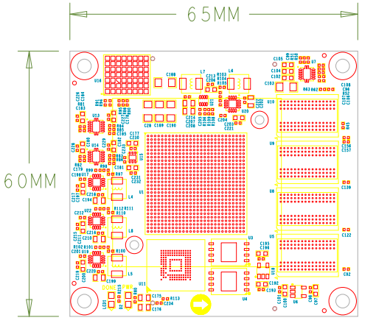

Front view (TOP View)

# expanding board

## Introduction

Through the previous function introduction, we can understand the functions of the expansion board

* 2-way Gigabit Ethernet RJ-45 interface
* PCIe 3.0 x 4 interface
* 2-way SFP+ high-speed optical fiber interface
* 1-way USB Uart debugging interface
* 1 USB HOST interface
* 1-way LVDS display interface
* 2-way MIPI camera interface
* 1-way Micro SD card holder
* JTAG debug port
* 1 way temperature sensor
* 1 channel EEPROM
* 1 channel CANFD communication interface
* 1 way 22-pin expansion port

## Gigabit Ethernet interface

There are two Gigabit Ethernet interfaces on the VD100 expansion board, one is connected to the PS end, and the other is connected to the PL end. Provide users with network communication services through Jinglue Semiconductor's industrial-grade Ethernet GPH Y chip ( JL2121 -N040I ). The JL2121 chip supports 10/100/1000 Mbps network transmission rate and communicates data with the MAC layer of the FPGA through the R GMII interface. JL2121D supports MDI/MDX adaptation, various speed adaptation, Master/ Slave adaptation, and supports MDIO bus for PHY register management.

JL2121 is powered on, it will detect the level status of some specific IOs to determine its own working mode . Table 3-2-1 Describes the default setting information of the GPHY chip after power-on.

|  |  |  |
| --- | --- | --- |
| **Configure pins** | **illustrate** | **configuration value** |
| RXD3_ADR0  RXC_ADR1  RXCTL_ADR2 | PHY address for MDIO/MDC mode | PHY Address is 0 01 |
| RXD1_TXDLY | TX clock 2ns delay | delay |
| RXD0_RXDLY | RX clock 2ns delay | delay |

Table 3-2-1 PHY chip default configuration values

When the network is connected to Gigabit Ethernet, the data transmission of FPGA and PHY chip JL2121 is communicated through the RGMII bus. The transmission clock is 125Mhz, and the data is sampled on the rising edge and downsampling of the clock.

When the network is connected to 100M Ethernet, the data transmission of FPGA and PHY chip JL2121 is communicated through RMII bus, and the transmission clock is 25Mhz. Data is sampled on the rising and falling edges of the clock.

The design diagram of Gigabit Ethernet is shown in Figure 3-2-1:



Figure 3-2-1 Gigabit Ethernet interface design diagram

**The Gigabit Ethernet pin assignments are as follows:**

|  |  |  |  |
| --- | --- | --- | --- |
| **Signal name** | **Pin name** | **Pin number** | **Remark** |
| PHY1_TXCK | LPD_MIO0 | T1 | Ethernet 1RGMII transmit clock |
| PHY1_TXD0 | LPD_MIO1 | U1 | Ethernet 1 sends data bit0 |
| PHY1_TXD1 | LPD_MIO2 | W1 | Ethernet 1 sends data bit1 |
| PHY1_TXD2 | LPD_MIO3 | Y1 | Ethernet 1 sends data bit2 |
| PHY1_TXD3 | LPD_MIO4 | Y2 | Ethernet 1 sends data bit3 |
| PHY1_TXCTL | LPD_MIO5 | W2 | Ethernet 1 sends enable signal |
| PHY1_RXCK | LPD_MIO6 | V2 | Ethernet 1RGMII receive clock |
| PHY1_RXD0 | LPD_MIO7 | U2 | Ethernet 1 receives data Bit0 |
| PHY1_RXD1 | LPD_MIO8 | T3 | Ethernet 1 receives data Bit1 |
| PHY1_RXD2 | LPD_MIO9 | U3 | Ethernet 1 receives data Bit2 |
| PHY1_RXD3 | LPD_MIO10 | V3 | Ethernet 1 receives data Bit3 |
| PHY1_RXCTL | LPD_MIO11 | Y3 | Ethernet 1 receives data valid signal |
| PHY1_MDIO | PS_MIO51 | AA10 | Ethernet 1MDIO management data |
| PHY1_MDC | PS_MIO50 | AB10 | Ethernet 1MDIO management clock |
| PHY1_RESET | LPD_MIO15 | T5 | Ethernet 1 reset signal |
| PHY2_TXCK | B302_L9_N | A13 | Ethernet 2 RGMII transmit clock |
| PHY2_TXD0 | B302_L8_N | A11 | Ethernet 2 sends data bit0 |
| PHY2_TXD1 | B302_L8_P | B11 | Ethernet 2 sends data bit1 |
| PHY2_TXD2 | B302_L7_N | A10 | Ethernet 2 sends data bit2 |
| PHY2_TXD3 | B302_L7_P | B10 | Ethernet 2 sends data bit3 |
| PHY2_TXCTL | B302_L9_P | B12 | Ethernet 2 sends enable signal |
| PHY2_RXCK | B302_L6_P | D10 | Ethernet 2 RGMII receive clock |
| PHY2_RXD0 | B302_L5_N | C12 | Ethernet 2 receives data Bit0 |
| PHY2_RXD1 | B302_L5_P | D11 | Ethernet 2 receives data Bit1 |
| PHY2_RXD2 | B302_L10_N | A14 | Ethernet 2 receive data Bit2 |
| PHY2_RXD3 | B302_L10_P | B13 | Ethernet 2 receive data Bit3 |
| PHY2_RXCTL | B302_L6_N | C10 | Ethernet 2 receives data valid signal |
| PHY2_MDIO | B302_L1_P | C14 | Ethernet 2 MDIO management data |
| PHY2_MDC | B302_L1_N | C13 | Ethernet 2 MDIO management clock |
| PHY2_RESET | B703_L12_P | H23 | Ethernet 2 reset signal |

## PCIe3.0 X4 interface

The VD100 expansion board provides an industrial-grade high-speed data transmission PCIe 3.0 x4 interface. The dimensions of the PCIE card comply with the electrical specifications of the standard PCIe card and can be used directly in the x4 PCIe slot of an ordinary PC.

The transceiver signals of the PCIe interface are directly connected to the GTY transceiver of the FPGA. The four-channel TX signal and RX signal are connected to the FPGA in a differential signal mode. The single-channel communication rate can be as high as 8 Gbit bandwidth. The PCIe reference clock is provided to the development board from the PCIe slot of the PC, and the reference clock frequency is 100Mhz.

The design schematic diagram of the PCIe interface of the development board is shown in Figure 3-3-1 below, in which the TX transmission signal and the reference clock CLK signal are connected in AC coupling mode.



Figure 3-3-1 PCIe x4 design diagram

**The PCIe x4 interface FPGA pin assignment is as follows:**

|  |  |  |
| --- | --- | --- |
| **network name** | **FPGA pin** | **Remark** |
| PCIE_RX0_P _ _ _ | P2 | PCIE channel 0 data receptionPositive |
| PCIE_RX0_N _ _ _ _ | P1 | PCIE channel 0 data reception Negative |
| PCIE_RX1_P _ _ _ | M2 | PCIE channel 1 data receptionPositive |
| PCIE_RX1_N _ _ _ _ | M1 | PCIE channel 1 data reception Negative |
| PCIE_RX2_P _ _ _ | K2 | PCIE channel 2 data receptionPositive |
| PCIE_RX2_N _ _ _ _ | K1 | PCIE channel 2 data reception Negative |
| PCIE_RX3_P _ _ _ | H2 | PCIE channel 3 data receptionPositive |
| PCIE_RX3_N _ _ _ _ | H1 | PCIE channel 3 data reception Negative |
| PCIE_TX0_P _ _ _ | N5 | PCIE channel 0 data transmission Positive |
| PCIE_TX0_N _ _ _ _ | N4 | PCIE channel 0 data transmission Negative |
| PCIE_TX1_P _ _ _ | L5 | PCIE channel 1 data transmission Positive |
| PCIE_TX1_N _ _ _ _ | L4 | PCIE channel 1 data transmission Negative |
| PCIE_TX2_P _ _ _ | J5 | PCIE channel 2 data transmission Positive |
| PCIE_TX2_N _ _ _ _ | J4 | PCIE channel 2 data transmission Negative |
| PCIE_TX3_P _ _ _ | G5 | PCIE channel 3 data transmission Positive |
| PCIE_TX3_N _ _ _ _ | G4 | PCIE channel 3 data transmission Negative |
| PCIE_CLK_P _ _ | M7 | PCIE reference clock Positive |
| PCIE_CLK_N _ _ | M6 | PCIE reference clock Negative |
| PCIE_PERST | B13 | PCIE reset signal |

## Optical fiber interface

There are 2 SFP+ optical fiber interfaces on the VD100 development board. Users can purchase SFP optical modules (1.25G, 2.5G, 10G optical modules on the market) and insert them into these two optical fiber interfaces for optical fiber data communication. The 2 optical fiber interfaces are connected to the 2 RX/TX of the GTY transceiver of FPGA's BANK104 respectively. The TX signal and the RX signal are connected to the FPGA and the optical module through DC blocking capacitors in the form of differential signals. Each TX transmits and RX receives data. Rates up to 10Gb/s. The reference clock of BANK104's GTY transceiver is provided by a 156.25Mhz differential crystal oscillator.

The schematic diagram of FPGA and SFP optical fiber design is shown in Figure 3-4-1 below:



Figure 3-4-1 Optical fiber design diagram

**The first optical fiber interface FPGA pin assignment is as follows:**

|  |  |  |
| --- | --- | --- |
| **network name** | **FPGA pin** | **Remark** |
| SFP 1_TX_P _ | E5 | SFP optical module data sendingPositive |
| SFP 1_TX_N _ _ | E4 | SFP optical module data sending Negative |
| SFP 1_R X_P _ _ | F2 | SFP optical module data receptionPositive |
| SFP 1_R X_N _ _ _ | F1 | SFP optical module data reception Negative |
| SFP 1_TX_DIS _ _ | D26 | SFP optical module light emission is disabled, low effective |
| SFP1_SCL _ _ _ | D21 | I2C clock signal |
| SFP 1_SDA _ _ | D20 | I2C data signal |

**The second optical fiber interface FPGA pin assignment is as follows:**

|  |  |  |
| --- | --- | --- |
| **network name** | **FPGA pin** | **Remark** |
| SFP 2_TX_P _ | D8 | SFP optical module data sendingPositive |
| SFP 2_TX_N _ _ | D7 | SFP optical module data sending Negative |
| SFP 2_R X_P _ _ | D2 | SFP optical module data receptionPositive |
| SFP 2_R X_N _ _ _ | D1 | SFP optical module data reception Negative |
| SFP 2_TX_DIS _ _ | D25 | SFP optical module light emission is disabled, low effective |
| SFP_CLK_N | H6 | FPGA input clock Negative |
| SFP_CLK_P | H7 | FPGA input clock Positive |

## USB to serial port

The VD100 expansion board is equipped with a Uart-to-USB interface connected to the PS side. The conversion chip uses the USB- UAR chip of Silicon Labs CP210 2 GM . The USB interface adopts the MINI USB interface. You can use a USB cable to connect it to the USB port of the PC for serial data communication.

The schematic diagram of USB Uart circuit design is shown in Figure 3-5-1 Figure 3-5-1 USB to serial port schematic diagram

**FPGA pin assignment for UART to serial port:**

|  |  |  |  |
| --- | --- | --- | --- |
| **Signal name** | **FPGA pin name** | **FPGA pin number** | **Remark** |
| PS_UART0_RX | LPD_MIO16 | U5 | Uart data input |
| PS_UART0_TX | LPD_MIO17 | V5 | Uart data output |

## USB2.0 interface

The VD100 expansion board has a USB2.0 interface and supports HOST working mode. USB2.0 connects to the external USB3320C chip through the ULPI interface to achieve high-speed USB2.0 data communication.

The USB interface is a flat USB interface (USB Type A) , which facilitates users to connect different USB Slave peripherals (such as USB mouse, keyboard or U disk) at the same time. The schematic diagram of USB2.0 connection is shown in 3-6-1:



3-6-1 USB3.0 interface diagram

**USB interface pin assignment:**

|  |  |  |  |
| --- | --- | --- | --- |
| Signal name | Pin name | Pin number | Remark |
| USB_DATA0 | PS_MIO14 | AC3 | USB2.0 Data Bit0 |
| USB_DATA1 | PS_MIO15 | AE3 | USB2.0 Data Bit1 |
| USB_DATA2 | PS_MIO16 | AF3 | USB2.0 Data Bit2 |
| USB_DATA3 | PS_MIO17 | AG3 | USB2.0 Data Bit3 |
| USB_DATA4 | PS_MIO19 | AH4 | USB2.0 Data Bit4 |
| USB_DATA5 | PS_MIO20 | AF4 | USB2.0 Data Bit5 |
| USB_DATA6 | PS_MIO21 | AE4 | USB2.0 Data Bit6 |
| USB_DATA7 | PS_MIO22 | AD4 | USB2.0 Data Bit7 |
| USB_STP | PS_MIO24 | AA4 | USB2.0 stop signal |
| USB_DIR | PS_MIO23 | AC4 | USB2.0 data direction signal |
| USB_CLK | PS_MIO18 | AH3 | USB2.0 clock signal |
| USB_NXT | PS_MIO25 | Y4 | USB2.0 next data signal |
| USB_RESET_N | PS_MIO13 | AB3 | USB2.0 reset signal |

## LVDS display interface

The expansion board contains an LVDS display interface, which can be used to connect our 7-inch display module (AN7000). The LVDS interface is a 40PIN FPC connector with 4 pairs of LVDS data, 1 pair of clocks, and other control signals connected to the differential IO pins of BANK703 through a level conversion chip. The level standard is 1.5V. Figure 3-7-1 LVDS interface design schematic diagram

LVDS **interface pin assignment**

|  |  |  |  |
| --- | --- | --- | --- |
| **Signal name** | **Pin name** | **Pin number** | **Remark** |
| LVDS_CLK- | B703_L17_N | A24 | LVDS screen input clock negative |
| LVDS_CLK+ | B703_L17_P | A23 | LVDS screen input clock is positive |
| LVDS_D0- | B703_L13_N | G23 | The data input on the LVDS screen DATA0 is negative |
| LVDS_D0+ | B703_L13_P | F22 | The data input on the LVDS screen DATA0 is positive |
| LVDS_D1- | B703_L22_N | A21 | The data input on the LVDS screen DATA1 is negative |
| LVDS_D1+ | B703_L22_P | A20 | The data input on the LVDS screen DATA1 is positive |
| LVDS_D2- | B703_L23_N | B22 | Data input on the LVDS screen DATA2 negative |
| LVDS_D2+ | B703_L23_P | C22 | The data input on the LVDS screen DATA2 is positive |
| LVDS_D3- | B703_L10_N | A26 | Data input on the LVDS screen DATA3 negative |
| LVDS_D3+ | B703_L10_P | A25 | The data input on the LVDS screen DATA3 is positive |
| FPGA_LCD_SDI | B703_L11_N | B27 | LCD screen serial interface address and SPI data input |
| FPGA_LCD_CSB | B703_L11_P | B26 | LCD screen serial interface chip SPl chip select signal |
| FPGA_LCD_SCL | B703_L3_N | E28 | LCD screen serial interface SPI clock |
| FPGA_LCD_SDO | B703_L9_N | B25 | LCD screen serial interface SPI data output |
| FPGA_LCD_RESET | B703_L3_P | E27 | LCD screen reset signal |
| FPGA_LCD_STBYB | B703_L25_N | F25 | LCD screen mode setting signal |
| FPGA_BANKLCD_SDA | B703_L12_N | H24 | Backlight I2C data |
| FPGA_BANKLCD_SCL | B703_L14_P | E22 | Backlight I2C clock |
| FPGA_BANKLCD_INT | B703_L9_P | C25 | Backlight failure interrupt signal |
| FPGA_BANKLCD_EN | B703_L25_P | E24 | Backlight enable signal |
| FPGA_BANKLCD_PWM | B703_L15_N | C24 | Backlight brightness adjustment signal |
| FPGA_BANKLCD_SYNC | B703_L15_P | D24 | Backlight sync boost input |
| LVDS_CLK_N | B703_L24_N | F24 | FPGA input clock negative |
| LVDS_CLK_P | B703_L24_P | F23 | FPGA input clock is positive |

## MIPI interface

The VD100 expansion board contains 2 MIPI 4 Lane camera interfaces, which can be used to connect our MIPI OS05A10 camera module (AN5010). The MIPI interface is a 20PIN FPC connector, which is connected to the differential IO pins of BANK702 for 4 LANE data and 1 pair of clocks. The level standard is 1.2V; other control signals are connected to the IO of BANK703 through level conversion. on, the level standard is 1.5V.

 Figure 3-8-1 MIPI interface design schematic diagram

**MIPI interface pin assignments**

|  |  |  |  |
| --- | --- | --- | --- |
| **Signal name** | **Pin name** | **Pin number** | **Remark** |
| MIPI1_CLK_N | B702_L12_N | T24 | MIPI1 input clock negative |
| MIPI1_CLK_P | B702_L12_P | U23 | MIPI1 input clock positive |
| MIPI1_LAN0_N | B702_L13_N | R24 | MIPI1 input data LANE0 negative |
| MIPI1_LAN0_P | B702_L13_P | T23 | MIPI1 input data LANE0 positive |
| MIPI1_LAN1_N | B702_L14_N | P24 | MIPI1 input data LANE1 negative |
| MIPI1_LAN1_P | B702_L14_P | R23 | MIPI1 input data LANE1 positive |
| MIPI1_LAN2_N | B702_L16_N | K24 | MIPI1 input data LANE2 negative |
| MIPI1_LAN2_P | B702_L16_P | L23 | MIPI1 input data LANE2 positive |
| MIPI1_LAN3_N | B702_L15_N | M23 | MIPI1 input data LANE3 negative |
| MIPI1_LAN3_P | B702_L15_P | M22 | MIPI1 input data LANE3 positive |
| MIPI1_SDA | B703_L2_N | F28 | I2C data for MIPI1 camera |
| MIPI1_SCL | B703_L2_P | G27 | I2C clock for MIPI1 camera |
| MIPI1_GPIO | B703_L7_N | G26 | GPIO control of MIPI1 camera |
| MIPI1_CLK | B703_L7_P | G25 | MIPI1 camera clock input |
| MIPI2_CLK_N | B702_L18_N | U22 | MIPI2 input clock negative |
| MIPI2_CLK_P | B702_L18_P | V21 | MIPI2 input clock positive |
| MIPI2_LAN0_N | B702_L19_N | R22 | MIPI2 input data LANE0 negative |
| MIPI2_LAN0_P | B702_L19_P | T21 | MIPI2 input data LANE0 is positive |
| MIPI2_LAN1_N | B702_L20_N | P22 | MIPI2 input data LANE1 negative |
| MIPI2_LAN1_P | B702_L20_P | R21 | MIPI2 input data LANE1 positive |
| MIPI2_LAN2_N | B702_L21_N | M21 | MIPI2 input data LANE2 negative |
| MIPI2_LAN2_P | B702_L21_P | N21 | MIPI2 input data LANE2 positive |
| MIPI2_LAN3_N | B702_L22_N | L22 | MIPI2 input data LANE3 negative |
| MIPI2_LAN3_P | B702_L22_P | K21 | MIPI2 input data LANE3 positive |
| MIPI2_SDA | B703_L4_N | C28 | I2C data for MIPI2 camera |
| MIPI2_SCL | B703_L4_P | D27 | I2C clock for MIPI2 camera |
| MIPI2_GPIO | B703_L0_N | H28 | GPIO control of MIPI2 camera |
| MIPI2_CLK | B703_L0_P | J27 | MIPI2 camera clock input |

## SD card

The VD100 expansion board contains a Micro-type SD card interface to provide users with access to the SD card memory, which is used to store the BOOT program of the XCVE2302 chip and the Linux operating system kernel . file system and other user data files.

The SDIO signal is connected to the IO signal of PS BANK501 of XCVE2302 , because the VCCIO of 501 is set to 1.8V, but the data level of the SD card is 3.3V, we connect it here through the TXS02612 level converter . The schematic diagram of the XCVE2302 PS and SD card connector is shown in Figure 3-9-1 .



Figure 3-9 - 1 SD card connection diagram

**SD card slot pin assignment**

|  |  |  |  |
| --- | --- | --- | --- |
| **Signal name** | **Pin name** | **Pin number** | **Remark** |
| SD_CLK | PS_MIO26 | AA5 | SD clock signal |
| SD_CD | PS_MIO28 | AC5 | SD card detection signal |
| SD_CMD | PS_MIO29 | AD5 | SD command signal |
| SD_D0 | PS_MIO30 | AE6 | SD dataData0 |
| SD_D1 | PS_MIO31 | AD6 | SD dataData1 |
| SD_D2 | PS_MIO32 | AB6 | SD dataData2 |
| SD_D3 | PS_MIO33 | AA6 | SD dataData3 |

## EEPROM 24LC04 and temperature sensor

The VD100 development board is equipped with an EEPROM, model 24LC04, capacity: 4Kbit (2*256*8bit), which is connected to the PS side for communication through the IIC bus. In addition, the board also has a high-precision, low-power consumption, digital temperature sensor chip, model LM75 from ON Semiconductor. The temperature accuracy of the LM75 chip is 0.5 degrees. The EEPROM and temperature sensor are mounted to the Versal ACAP's Bank501 MIO via the I2C bus. Figure 3-10-1 is the schematic diagram of EEPROM and temperature sensor



Figure 3-10-1 Schematic diagram of EEPROM and sensor

**The EEPROM communication pin assignment is as follows:**

|  |  |  |  |
| --- | --- | --- | --- |
| Signal name | Pin name | Pin number | Remark |
| PS_IIC1_SCL | PS_MIO34 | AB7 | I2C clock signal |
| PS_IIC1_SDA | PS_MIO35 | AC7 | I2C data signal |

## JTAG interface

The development board reserves a JTAG interface for downloading FPGA programs or firmware programs to FLASH. In order to prevent damage to the FPGA chip caused by hot plugging and unplugging, we added a protection diode to the JTAG signal to ensure that the signal voltage is within the acceptable range of the FPGA and avoid damage to the FPGA.

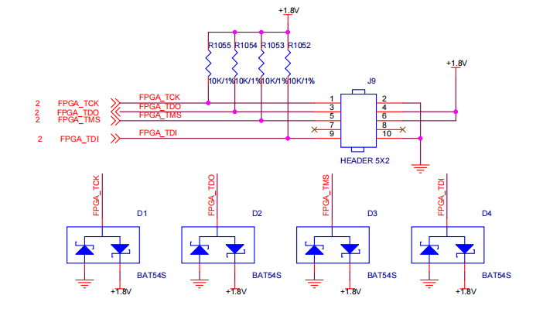

Figure 3-8-1 JTAG interface schematic diagram

Be careful not to hot-swap when plugging or unplugging the JTAG line.

## CANFD communication interface

The VD100 expansion board has 1 CAN/CANFD communication interface, which is connected to the MIO interface of BANK502 on the PS system side. The CANFD transceiver chip uses the TJA1051T/3/1J chip of Zhienpu Company to provide user CAN communication services.

Figure 3-12-1 is the connection diagram of the CAN transceiver chip on the PS side.



Figure 3-12-1 Connection diagram of PS-side CAN transceiver chip

**The CAN communication pin assignment is as follows:**

|  |  |  |  |
| --- | --- | --- | --- |
| **Signal name** | **Pin name** | **Pin number** | **Remark** |
| CANFD_TXD1 | LPD_MIO23 | Y7 | CAN1 sending end |
| CANFD_RXD1 | LPD_MIO22 | T6 | CAN1 receiving end |

## PMOD expansion port

The expansion board reserves a 12PIN 2.54mm standard spacing PMOD expansion port J55 for connecting external modules or devices. The expansion port has 2 channels of 3.3V power supply, 2 channels of ground, and 8 channels of IO port. The IO level standard is 3.3V. **Do not connect it directly to the IO of a 5V device to avoid burning out the FPGA. If you want to connect the IO of a 5V device, you need to connect a level conversion chip.**

The circuit of the expansion port (55) is shown in Figure 3-13-1 below

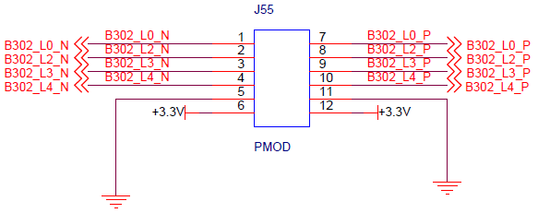

Figure 3-13-1 Schematic diagram of expansion port J55

**J55 expansion port FPGA pin assignment**

|  |  |  |  |  |  |
| --- | --- | --- | --- | --- | --- |
| **J55 pin number** | **FPGA**  **Pin name** | **FPGA**  **Pin number** | **J55 pin number** | **FPGA**  **Pin name** | **FPGA**  **Pin number** |
| 1 | B302_L0_N | E14 | 7 | B302_L0_P | F14 |
| 2 | B302_L2_N | D14 | 8 | B302_L2_P | E13 |
| 3 | B302_L3_N | D12 | 9 | B302_L3_P | E12 |
| J4 | B302_L4_N | E11 | 10 | B302_L4_P | F11 |
| 5 | land | - | 11 | land | - |
| 6 | +3.3V | - | 12 | +3.3V | - |

## button

The expansion board contains two user buttons KEY1~KEY2. Both buttons are connected to the ordinary IO of the FPGA, one is connected to the PL side and the other is connected to the PS side. The low level of the button is active. When the button is pressed, the IO input voltage of the FPGA is low. When no button is pressed, the IO input voltage of the FPGA is high. The circuit of the button part is shown in Figure 3-10-1 below



Figure 3-14-1 Button hardware design diagram

**Button FPGA pin assignment:**

|  |  |  |  |
| --- | --- | --- | --- |
| **Signal name** | **FPGA pin name** | **FPGA pin number** | **Remark** |
| PS_LED1 | LPD_MIO25 | Y9 | User button 1 |
| PL_KEY1 | B703_L19_N | F21 | User button 2 |

## LED light

There are three red LED lights on the expansion board, one of which is the power indicator light (PWR) and two of which are user LED lights (LED1~LED2). When the development board is powered on, the power indicator light will light up. User LED1~LED2 are connected to the common IO of the FPGA, one is connected to the PL terminal, and the other is connected to the PS terminal. When the IO voltage connected to the user LED light is configured as high level, the user LED light lights up. When the connected IO voltage is configured as When low, the user LED will be turned off. The schematic diagram of LED light hardware connection is shown in Figure 3-11-1



Figure 3-15-1 LED light hardware design schematic diagram

**LED FPGA pin assignment:**

|  |  |  |  |
| --- | --- | --- | --- |
| **Signal name** | **FPGA pin name** | **FPGA pin number** | **Remark** |
| PS_LED1 | LPD_MIO25 | Y9 | User defined indicator light |
| PL_LED1 | B703_L19_P | E20 | User defined indicator light |

## Power supply

The power input voltage of the development board is DC12V. Please use the power supply that comes with the development board. Do not use power supplies of other specifications to avoid damaging the development board. The expansion board converts the three-way DC/DC power chip ETA1471FT2G into three-way power supplies of +5V, +3.3V, and +1.8V, and then converts +3.3V into +1.5V through the LDO power chip SPX3819M5-1-5. In addition, the +12V power supply on the expansion board supplies power to the core board through the inter-board connector. The power supply design on the expansion board is shown in Figure 3-12-1 below.



Figure 3-16-1 Expansion board power supply schematic diagram

## Structural dimension drawing

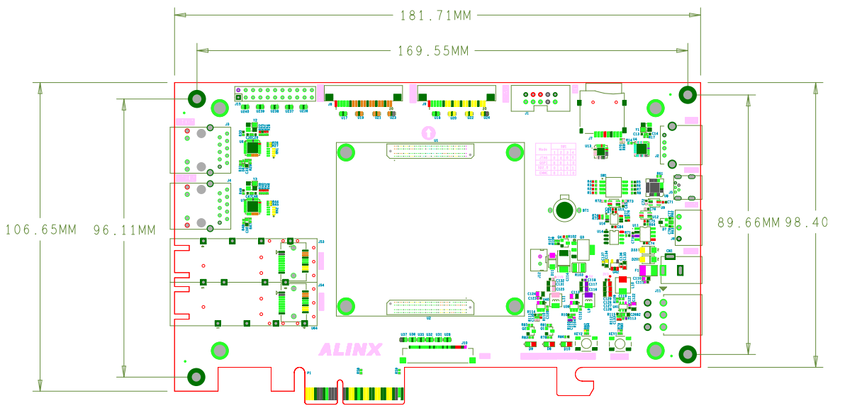

Top View